Chapter 19, Problem 41.

For the two-port in Fig.19.75, show that

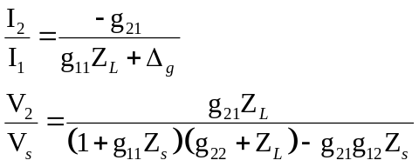

where Δ_{g} is the determinant of [g] matrix.

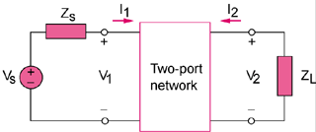

Figure 19.75
For Probs. 19.14 and 19.41.

